Arrays and functions

1) Write a program,

a. Where a function adds all the elements in an array.

b. The function should display the sum of elements.

c. Make 2 function calls with array elements- (1, 2, 3) and (4, 5, 6).

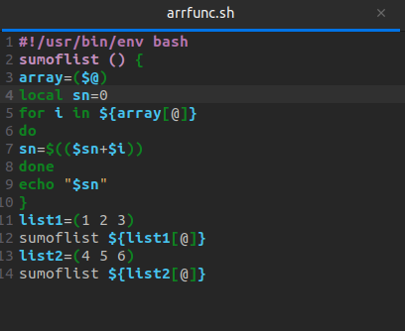

Terminal

